Games Engine Creation

Portfolio

Student Name: Charlotte Marriner

Student Number: 19023143

Contents

Chapter 1: Introduction

Chapter 2: Data Types

Chapter 3: Variables

Chapter 4: Operators

Chapter 5: Conditionals

Chapter 6: Loops

Chapter 7: Functions

Chapter 8: Arrays

Chapter 9: Strings

Chapter 10: Debugging

Chapter 11: Structures

Chapter 12: Pointers

Chapter 13: References

Chapter 14: File Handling

Chapter 15: Object Oriented Programming

Appendices: Full game listings

Chapter 1: Introduction

To begin we will be going through the steps required to build a simple application in C++ using Visual Studio. This will be the class ‘Hello World’ program. This will go through the steps required to create a new program and how to add source files.

NOTE: There is one function in the HelloWorld program. It is called main(). All programs must have a main function as this is where execution of the program begins. There can only be 1 main function in any given program.

**Program 1: Hello World**

1. To begin, start Visual Studio.
2. Create a new project via File -> New -> Project or Ctrl+Shift+N. Name it “Chapter1_HelloWorld”
3. Click **Next** and you should be greeted with the following screen. Make sure to have **Empty Project** ticked and click **Finish**.

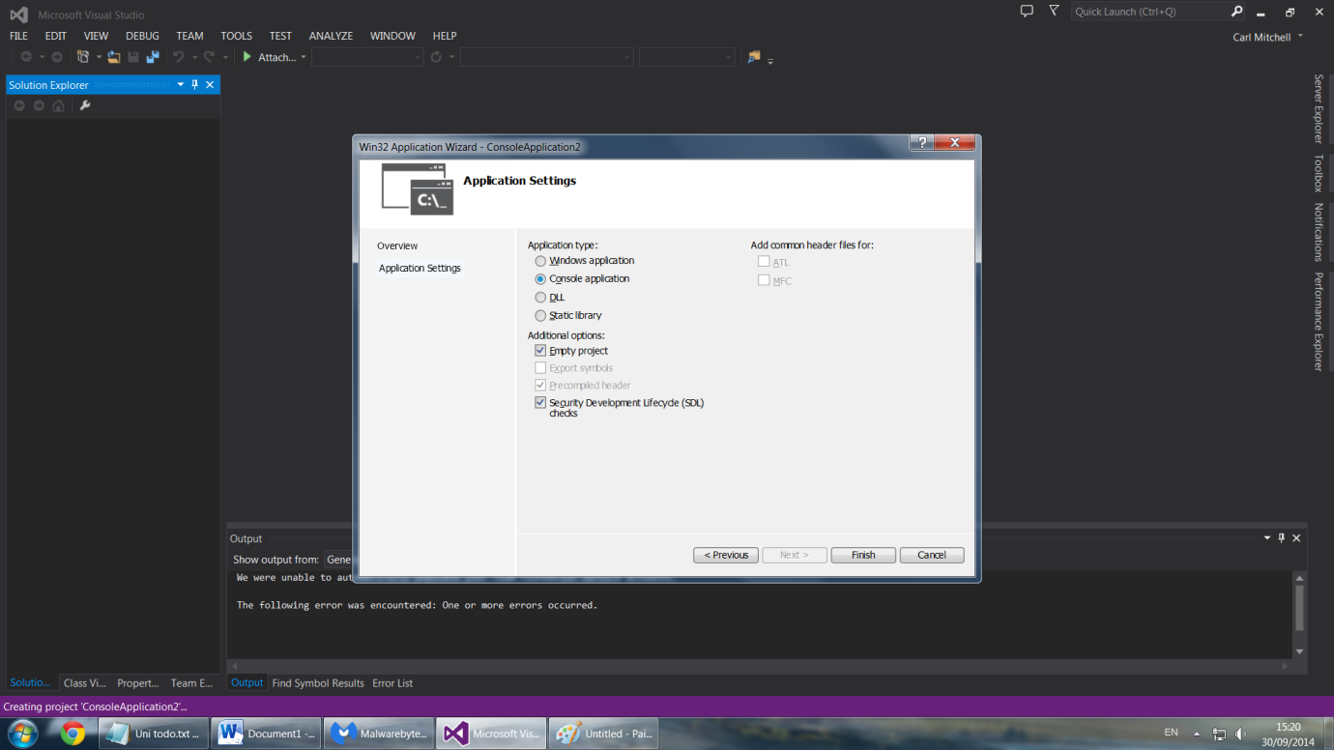

1. You should now have a set of project folders on the side (Header Files, Resource Files, Source Files, etc). Right click **Source Files** and choose **Add -> New Item**. Then select **CPP file** (should be selected by default). Name it “helloworld.cpp”
2. The file you’ve just created should open up in the text editor section automatically. This is where you can begin typing the code.
3. Replicate program listing 1. Do not worry about the various elements of the program, these will be explained in detail later.

NOTE: Quick code overview. **cout** outputs to the console screen. **<<** seperates the command and the string to output. **endl** adds a carriage return after the output. **cin.get()** awaits input from the user and stops the program automatically closing. Return 0 is the value returned. If you notice before main it states the return type, in this instance an int. So an int must be returned.

#include <iostream>

int main()

{

std::cout << "Hello World!" << std::endl;

std::cin.get();

return 0;

}

Program Listing 1

1. That is the entire program. To run it, left-click **DEBUG** in the menubar, and then left-click **Run** in the submenu to compile and execute the program.
2. At this point, you should see a message box asking you if you would like to build the project. Left-click the **Yes** button to continue.
3. If you have typed or copied the program correctly, it should compile and execute, and you should see the console window with the message "Hello World!" in it.

